### **Education**

**2021: Graduate of QA training, College of Automation –** [**www.automation.co.il**](http://www.automation.co.il)

**Knowledge and practical experience** in the following subjects:

* Construction of test scripts including detailed writing of **STP** and **STD**
* Running tests on several products and applications on **Mobile** (**iOS**, **Android**) and **Browsers** (**Chrome**, **IE**, **Edge**, **FF**)
* Actual experience in the testing process including managing tests in **TestRail**, debugging reports in **Jira** and **monday.com** and writing **STR**
* Experience working with **HTML** and **CSS,** including building a [profile site](https://leviaps.github.io/My-Resume/)
* Working with **SQL** (excellent knowledge up to the **Join** level)

**2020: Basic Python course, she codes;**

**Knowledge and practical experience** in the following topics:

* **Variables, Control flow & Functions, Lists, Dictionaries & Tuples, Strings, Loops**

**2009 – 2011: MBA – Master's degree in Business Administration, ruppin Academic center**

Specialization in **Management and Organizational Development**, Marketing Management and International Business

**2000 – 2004: B.Ed: Bachelor's degree in special education, Oranim College**

### **Experience**

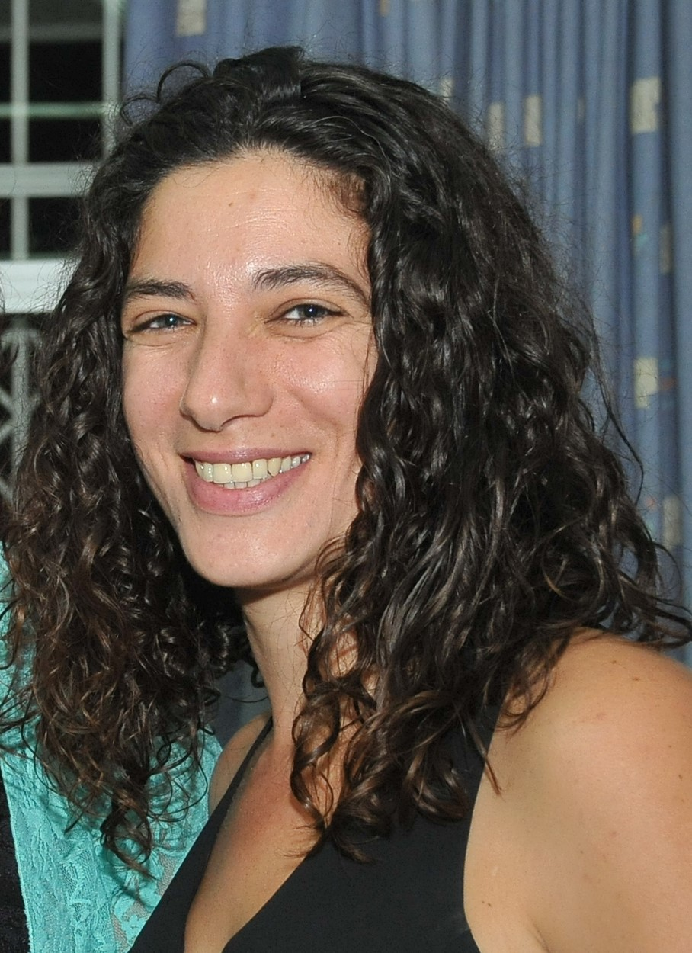

**ProfeSsion**

QA Engineer

# **Objective**

Seeking an entry-level position in Quality Assurance

## **Technical Skills**

Python, SQL, HTML, CSS, Git, TestRail, JIRA, monday.com, Advanced level Excel, Microsoft 365, Advanced level English

## **Skills & Abilities**

Detail oriented, curious and thorough, analytical mind, understands the big picture and manages to find the quality bugs.

## **contact info**

Haifa, Israel

+972 50 972 1115

[lpartushe@gmail.com](mailto:lpartushe@gmail.com)

[LinkedIn](https://www.linkedin.com/in/leviaps/)

**2015 – 2021: leader of Mathematics Teachers, Ministry of Education*:***

* Training of mathematics teachers: building study units and using existing **eLearning** **software**: **Class-e**, **Blossom**
* Building statistical tools for processing large data sets using **Excel &** **Google Sheets**
* Online training sessions using **Zoom, Google Meet & Microsoft Teams**
* Creating Online tutorials on **YouTube & Crello**
* Creating interactive presentations with **PowerPoint, Google Slides & Genial.ly**
* Cloud services: **Moodle, Google Drive, Dropbox, OneDrive**

**2016 – 2018: Deputy Principal of Elementary School, Ministry of Education:**

* Leading the teaching staff in pedagogy and practical teaching tools
* Management of school systems in **EduSystems** **software**

**2004 – 2014: Mathematics Coordinator, The Hebrew Reali School of Haifa:**

* Building school curricula based on **data** and processed **statistics**
* Writing study units in **eLearning software**